MY PROJECTS

About Me

Hi! I’m Can. I’m a software developer. I’m 26 years old. From games to full stack development, I am developing softwares. I mostly use Flutter. I developed real world business applications using Flutter and various databases, including Firebase. On the other hand, I love creating art. I play my guitar when I’m not working and listen music a lot. I love fitness and I like to read books.

İşim Benim

2020

# ABOUT

İşim Benim is a recruiting app that I was developing for a school project. It improved my Flutter skills more. This application was simply just getting it’s data and printing it on Card widgets. App has an bottom navigation bar. With this, I gained hands-on experience in developing with Flutter.

This application is developed with Flutter using Provider and BLoCs. This app uses Firebase as it’s database. BLoC’s are used in authentication and handling the user data. App used it’s own libraries in front-end part. Libraries are great tools to use to not repeat the code. Anyway, these were basically functions that were coloring texts, widgets etc. Algolia is used as the search engine of the application. Google Maps SDK is used. Geolocation packages of Flutter, which of them I don’t know anyway, are used to calculate the location. The data were coming from Firebase. The whole UI and colors designed by me. It’s pretty bad to me now. Here is some of the screenshots below this page.

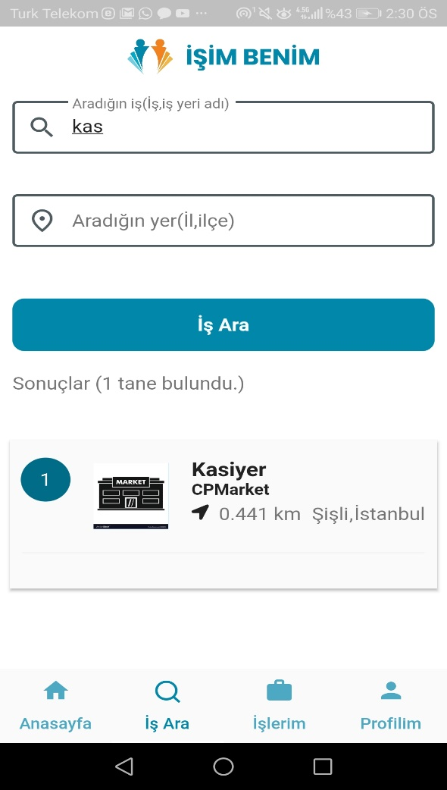 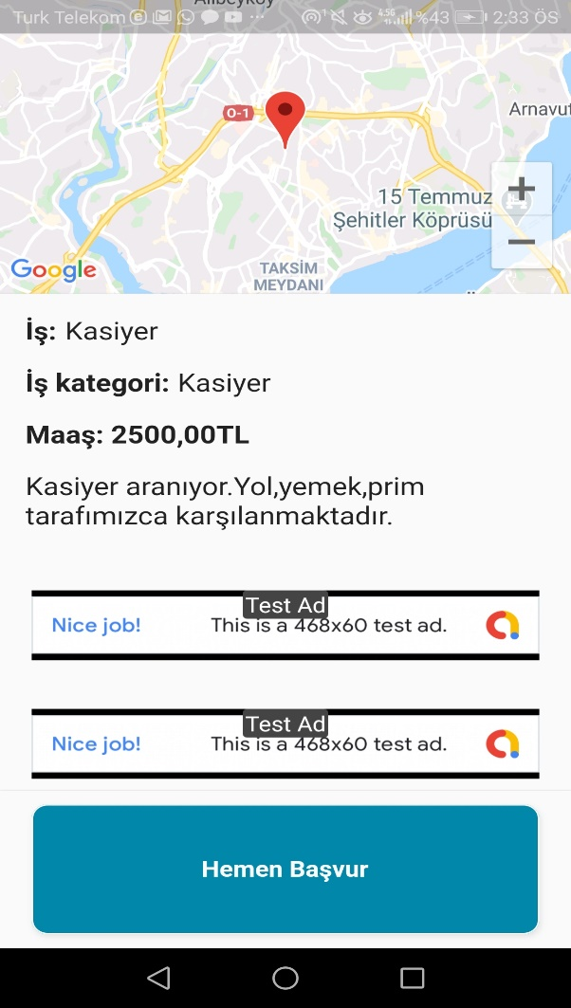

İşim Benim v1.0.0 – Job Search and Apply Screens

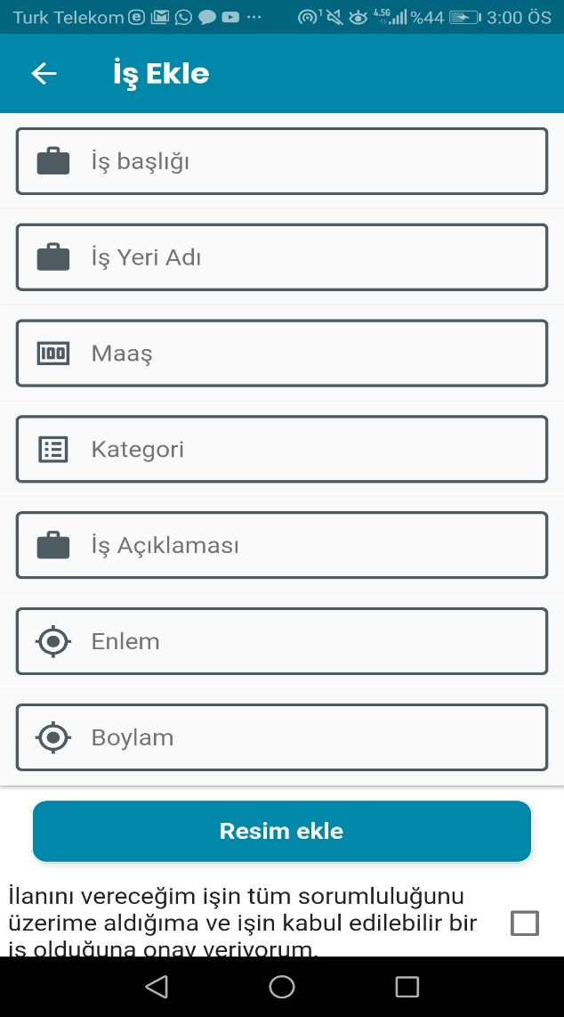

İşim Benim v1.0.0 – For Employers, Add Job Screen

# CONTACT

E-mail: cpehlivan544@gmail.com